St Andrew's Church

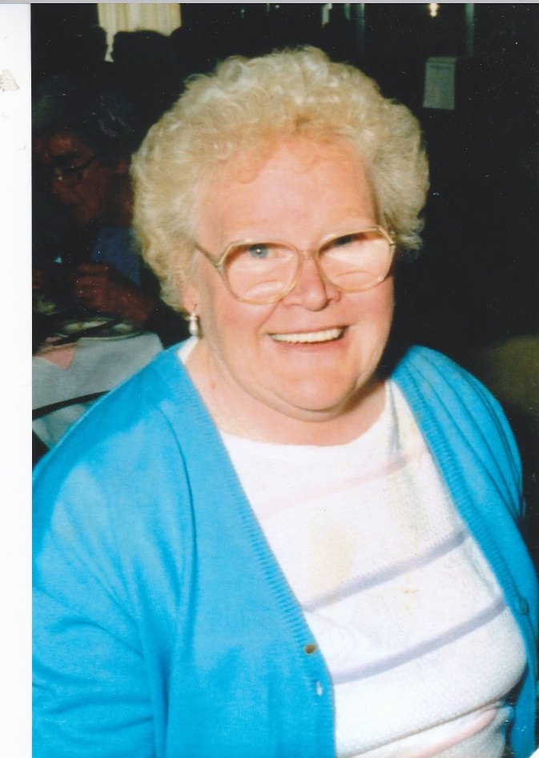Orford with Longford

Requiem for the soul of

Etheline (Ett) Worrall

13th February 1925 to 17th February 2017

Thursday 9th March 2017

## C:\WINDOWS\TEMP\\msotw9_temp0.jpgTHE GATHERING

*When all are gathered in church:*

Priest: God so loved the world that he gave his only Son, so that everyone who believes in him may not perish but may have eternal life.

We meet in the name of Jesus Christ, who died and was raised to the glory of God the Father. Grace and mercy be with you

All: and also with you.

*The priest introduces the service*

**Introit Hymn:**

Be still, for the presence of the Lord, the Holy One is here;

Come bow before him now with reverence and fear.

In Him no sin is found, we stand on holy ground;

Be still, for the presence of the Lord, the Holy One is here.

Be still, for the glory of the Lord, is shining all around;

He burns with holy fire, with splendour He is crowned.

How awesome is the sight, our radiant King of light;

Be still, for the glory of the Lord, is shining all around.

Be still, for the power of the Lord is moving in this place;

He comes to cleanse and heal, to minister His grace.

No work too hard for Him, in faith receive from Him;

Be still, for the power of the Lord is moving in this place.

#### Prayers of Penitence

Priest: As children of a loving heavenly Father, let us ask his forgiveness, for he is gentle and full of compassion.

(After a period of silent reflection)

All: Most merciful God, Father of our Lord Jesus Christ, we confess that we have sinned in thought, word and deed. We have not loved you with our whole heart. We have not loved our neighbours as ourselves. In your mercy forgive what we have been, help us to amend what we are, and direct what we shall be; that we may do justly, love mercy, and walk humbly with you, our God. Amen

Priest: Almighty God, who forgives all who truly repent, have mercy upon you, pardon and deliver you from all your sins, confirm and strengthen you in all goodness, and keep you in life eternal; through Jesus Christ our Lord. **Amen.**

**Collect:** Merciful Father, hear our prayers and comfort us; renew our trust in your Son, whom you raised from the dead; strengthen our faith that Etheline and all who have died in the love of Christ will share in his resurrection; who lives and reigns with you, in the unity of the Holy Spirit, one God, now and for ever. **Amen**

## THE LITURGY OF THE WORD

Please sit for

**A reading from the first letter of Peter** *(1 Peter 1. 3-9)*

Praise be to the God and Father of our Lord Jesus Christ, who in his great mercy gave us new birth into a living hope by the resurrection of Jesus Christ from the dead. The inheritance to which we are born is one that nothing can destroy or spoil or wither. It is kept for you in heaven, and you, because you put your faith in God, are under the protection of his power until salvation comes - the salvation which is even now in readiness, and will be revealed at the end of time.

This is cause for great joy, even though now you smart for a little while, if need be, under trials of many kinds. Even gold passes through the assayer’s fire, and more precious than perishable gold is faith that has stood the test. These trials come so that your faith may prove itself worthy of all praise, glory and honour when Jesus Christ is revealed.

You have not seen him, yet you love him; and trusting in him now without seeing him, you are transported with joy too great for words, while you reap the harvest of your faith, that is, salvation for your souls.

This is the word of the Lord.

All: Thanks be to God.

**Gradual hymn:** *(please stand)*

The Lord's my Shepherd, I'll not want;

he makes me down to lie -

in pastures green; he leadeth me -

the quiet waters by.

My soul he doth restore again,

and me to walk doth make -

within the paths of righteousness,

e'en for his own name's sake.

Yea, though I walk through death's dark vale,

yet will I fear no ill;

for thou art with me, and thy rod -

and staff me comfort still.

My table thou hast furnished

in presence of my foes;

my head thou dost with oil anoint ,

and my cup overflows.

Goodness and mercy all my life

shall surely follow me;

and in God's house, for evermore

my dwelling place shall be.

#### THE GOSPEL

Priest: Alleluia, alleluia. God so loved the world that he gave his only Son.

All: Alleluia.

Hear the Gospel of our Lord Jesus Christ according to John *(Jn 6. 35-40)*

All: Glory to you, O Lord

Then Jesus declared, “I am the bread of life. Those who come to me will never go hungry, and those who believe in me will never be thirsty. But as I told you, you have seen me and still you do not believe. All that the Father gives me will come to me and whoever comes to me I will never drive away. For I have come down from heaven not to do my will but to do the will of him who sent me, and this is the will of him who sent me, that I shall lose none of all that he has given me , but raise them up at the last day. For my Father’s will is that everyone who looks to the Son and believes in him shall have eternal life . And I will raise them up at the last day.

Priest: This is the Gospel of the Lord

All: Praise to you, O Christ

#### The Eulogy

#### The Prayers

Priest: Let us pray

Leader: God of mercy, Lord of life, you have made us in your image to reflect your truth and light: we give you thanks for Ett, for the grace and mercy she received from you, for all that was good in her life and for the memories we treasure today. Especially we thank you for her example of faith and fun; for her love of music and all that she has done to build up the life of this church, and for her dedication to, and love for, her family.

Leader: Lord in your mercy

All: hear our prayer.

Leader: Heavenly Father, you promised eternal life to those who believe. Remember for good this your daughter Ettas we also remember her. Hear all our prayers for those who have died and especially for Ett’s husband Ron and for those who come to mind at this time. Bring all who rest in Christ into the fullness of your kingdom where sins have been forgiven and death is no more.

Leader: Lord in your mercy

All: hear our prayer.

Leader: Loving Father, your mighty power brings joy out of grief and life out of death. Look in mercy on Ron and Carolyn, Thomas, Alistair, Andrew and Jennie and all who mourn at this time. Give them patient faith in times of darkness. Strengthen them with the knowledge of your love.

Leader: Lord in your mercy,

All: hear our prayer.

Leader: Father, you are tender towards your children and your mercy is over all your works. Heal the memories of hurt and failure. Give us the wisdom and grace to use aright the time that is left to us here on earth, to turn to Christ and follow in his steps in the way that leads to everlasting life.

Leader: Lord in your mercy,

All: hear our prayer.

All: God of mercy, entrusting into your hands all that you have made

and rejoicing in our communion with all your faithful people,

we make our prayers through Jesus Christ our Saviour. Amen.

## THE LITURGY OF THE SACRAMENT

#### The Peace *(please stand)*

Priest: Jesus says: Peace I leave with you; my peace I give to you. Not as the world gives do I give you. Do not let your hearts be troubled, neither let them be afraid.

The peace of the risen Lord be always with you

All: and also with you.

Priest: Let us offer one another a sign of peace.

Everyone is invited to share the peace with one another.

**Offertory Hymn:**

I, the Lord of sea and sky

I have heard my people cry.

All who dwell in dark and sin

my hand will save.

I who made the stars of night,

I will make their darkness bright.

Who will bear my light to them?

Whom shall I send?

*Here I am, Lord. Is it I Lord?*

*I have heard you calling in the night.*

*I will go Lord, if you lead me.*

*I will hold your people in my heart.*

I the Lord of snow and rain,

I have borne my people’s pain.

I have wept for love of them.

They turn away.

I will break their hearts of stone,

give them hearts for love alone.

I will speak my word to them.

Whom shall I send?

I, the Lord of wind and flame,

I will tend the poor and lame.

I will set a feast for them.

My hand will save.

Finest bread I will provide

till their hearts are satisfied.

I will give my life to them.

Whom shall I send?

#### EUCHARISTIC PRAYER E *(please kneel)*

Priest: The Lord is here.

All: His Spirit is with us.

Priest: Lift up your hearts.

All: We lift them to the Lord.

Priest: Let us give thanks to the Lord our God.

All: It is right to give thanks and praise.

Priest: Blessed are you, gracious God, creator of heaven and earth, giver of life, and conqueror of death. By his death on the cross, your Son Jesus Christ offered the one true sacrifice for sin, breaking the power of evil and putting death to flight. With all your saints

All: we give you thanks and praise.

Priest: Through his resurrection from the dead you have given us new birth into a living hope, into an inheritance which is imperishable, undefiled, and unfading. With all your saints

All: we give you thanks and praise.

Priest: The joy of resurrection fills the universe, and so we join with angels and archangels, with Ett and all your faithful people, evermore praising you and saying:

All: Holy, holy, holy Lord, God of power and might, heaven and earth are full of your glory. Hosanna in the highest. Blessed is he who comes in the name of the Lord. Hosanna in the highest.

Priest: We praise and bless you, loving Father, through Jesus Christ, our Lord; and as we obey his command, send your Holy Spirit, that broken bread and wine outpoured may be for us the body and blood of your dear Son.

On the night before he died he had supper with his friends and, taking bread, he praised you. He broke the bread, gave it to them and said: Take, eat; this is my body which is given for you; do this in remembrance of me.

When supper was ended he took the cup of wine. Again he praised you, gave it to them and said: Drink this, all of you; this is my blood of the new covenant, which is shed for you and for many for the forgiveness of sins. Do this, as often as you drink it, in remembrance of me.

So, Father, we remember all that Jesus did, in him we plead with confidence his sacrifice made once for all upon the cross. Bringing before you the bread of life and cup of salvation, we proclaim his death and resurrection until he comes in glory.

Priest: Praise to you, Lord Jesus:

All: Dying you destroyed our death, rising you restored our life:

Lord Jesus, come in glory.

Priest: Lord of all life, help us to work together for that day when your kingdom comes and justice and mercy will be seen in all the earth. Look with favour on your people, gather us in your loving arms and bring us with St Andrew and all the saintsto feast at your table in heaven. Through Christ, and with Christ, and in Christ, in the unity of the Holy Spirit, all honour and glory are yours, O loving Father, for ever and ever. **Amen.**

Priest: Let us pray with confidence as our Saviour taught us

All: Our Father, who art in heaven, hallowed be thy name; thy kingdom come; thy will be done; on earth as it is in heaven. Give us this day our daily bread. And forgive us our trespasses, as we forgive those who trespass against us. And lead us not into temptation; but deliver us from evil. For thine is the kingdom, the power and the glory, for ever and ever. Amen.

Priest: Every time we eat this bread and drink this cup,

All: we proclaim the Lord’s death until he comes.

All: Lamb of God, you take away the sin of the world, have mercy on us.

Lamb of God, you take away the sin of the world, have mercy on us.

Lamb of God, you take away the sin of the world, grant us peace.

Priest: Jesus is the Lamb of God who takes away the sin of the world.

Happy are those who are called to his supper.

All: Lord, I am not worthy to receive you,

but only say the word and I shall be healed.

Holy Communion is administered at the front of Church. Everyone is warmly invited to receive Holy Communion at this Eucharist. Those who prefer to receive a blessing are also invited to come forward at the same time.

## Prayer After Communion:

Priest: Let us pray: Gracious God, we thank you that in your great love you have fed us with the spiritual food and drink of the body and blood of your Son Jesus Christ and have given us a foretaste of your heavenly banquet: grant that this sacrament may be to us a comfort in affliction and a pledge of our inheritance in that kingdom where there is no death, neither sorrow nor crying, but fullness of joy with all your saints; through Jesus Christ our Saviour. **Amen**

All: Heavenly Father, in your Son Jesus Christ you have given us a true faith and a sure hope. Strengthen this faith and hope in us all our days, that we may live as those who believe in the communion of saints, the forgiveness of sins and the resurrection to eternal life; through Jesus Christ our Lord. Amen.

**Hymn:** The day thou gavest, Lord, is ended,

the darkness falls at thy behest;

to thee our morning hymns ascended,

thy praise shall sanctify our rest.

We thank that thy Church unsleeping,

while earth rolls onward into light,

through all the world her watch is keeping,

and rests not now by day nor night.

As o'er each continent and island

the dawn leads on another day,

the voice of prayer is never silent,

nor dies the strain of praise away.

The sun that bids us rest is waking -

our brethren 'neath the western sky,

and hour by hour fresh lips are making -

thy wondrous doings heard on high.

So be it, Lord; thy throne shall never,

like earth's proud empires, pass away;

thy kingdom stands, and grows for ever,

till all thy creatures own thy sway

## The Commendation

Priest:Let us commend ett to the mercy of God our maker and redeemer.

With this water we call to mind Etheline’s baptism. As Christ went through the deep waters of death for us, so may he bring us to the fullness of resurrection life with Ett and all the redeemed.

God our creator and redeemer, by your power Christ conquered death and entered into glory. Confident of his victory and claiming his promises, we entrust Ettto your mercy in the name of Jesus our Lord, who died and is alive and reigns with you, now and for ever. **Amen**

May God, in his infinite love and mercy, bring the whole Church, living and departed in the Lord Jesus, to a joyful resurrection, and the fulfilment of his eternal kingdom. **Amen.**

*­­­­­­­­­­­­­­­­­­­­­­­­­­­­­­­­­­­­-------------------------------------------------------------------------------------------------------------------------------------------------------------------------------------------------------------------------------------------------*

*Material Common Worship: Services and Prayers for the Church of England (Church House Publishing, 2000) is copyright © The Archbishops' Council of the Church of England. Hymns are reproduced under CCLI licence No. 2101652*

The Committal will take place after the service in church.

Everyone is invited to join Ett’s family at Walton Lea **or** go straight to the Hall

which is the single-storey building in the church car park.

Tea and coffee will be available immediately after the service

and the reception will begin as soon as the family returns from Walton Lea.

**First (epistle) reading for the funeral of Ett Worrall**

**A reading from the first letter of Peter**

Praise be to the God and Father of our Lord Jesus Christ, who in his great mercy gave us new birth into a living hope by the resurrection of Jesus Christ from the dead. The inheritance to which we are born is one that nothing can destroy or spoil or wither. It is kept for you in heaven, and you, because you put your faith in God, are under the protection of his power until salvation comes - the salvation which is even now in readiness, and will be revealed at the end of time.

This is cause for great joy, even though now you smart for a little while, if need be, under trials of many kinds. Even gold passes through the assayer’s fire, and more precious than perishable gold is faith that has stood the test. These trials come so that your faith may prove itself worthy of all praise, glory and honour when Jesus Christ is revealed.

You have not seen him, yet you love him; and trusting in him now without seeing him, you are transported with joy too great for words, while you reap the harvest of your faith, that is, salvation for your souls.

Reader: This is the word of the Lord

All: Thanks be to God

**Gospel reading for the funeral of Ett Worrall**

Priest: Alleluia, alleluia.

God so loved the world that he gave his only Son.

All: Alleluia.

Hear the Gospel of our Lord Jesus Christ according to St John

All: Glory to you, O Lord

Then Jesus declared, “I am the bread of life. Those who come to me will never go hungry, and those who believe in me will never be thirsty. But as I told you, you have seen me and still you do not believe. All that the Father gives me will come to me and whoever comes to me I will never drive away. For I have come down from heaven not to do my will but to do the will of him who sent me, and this is the will of him who sent me, that I shall lose none of all that he has given me, but raise them up at the last day. For my Father’s will is that everyone who looks to the Son and believes in him shall have eternal life. And I will raise them up at the last day.

Priest: This is the Gospel of the Lord

All: Praise to you, O Christ